PROBLEM 1 COVER PAGE

PROBLEM 1 OUTPUT

COVER PAGE FOR PROBLEM 2

OUTPUT FOR PROBLEM 2 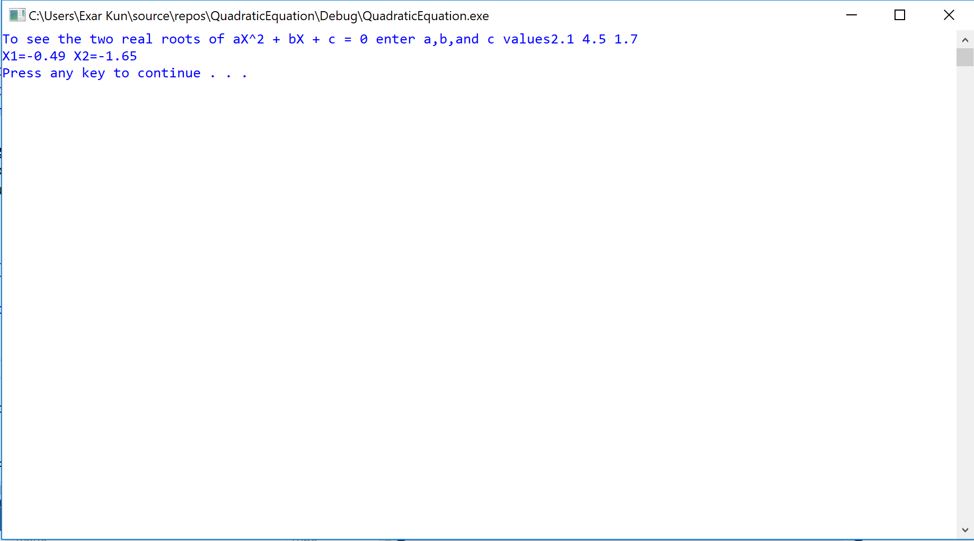

COVER PAGE FOR PROBLEM 3

OUTPUT FOR PROBLEM 3

